|  |  |  |
| --- | --- | --- |
| PHOTO-2020-11-21-20-50-59 | H. K. E. Society’s  Sir M. Visvesvaraya College of Engineering  (Affiliated to VTU - Belagavi, Approved by AICTE – New Delhi, Accredited by NAAC)  Yeramarus camp, Raichur – 584135 | C:\Users\Academics\Downloads\Logo PNG New.png |

**Report on**

“**Empower Her” Campaign**

Organised by Women Empowerment Cell H.K.E. Society’s Sir M. Visvesvaraya College of Engineering, on 21/10/24 from 2:30 pm onwards in Seminar hall.

The Session started with welcome note by Prof. Bassamma Patil, WEC chairperson, addressing all the Staff and students about importance of the Campaign, its objectives, background and implementation strategy.

**"Empower Her" Campaign in Colleges**

The "Empower Her" campaign aims to generate employment opportunities for women through active participation from college students.

This initiative focuses on two **primary objectives:**

1. Economic Empowerment of Women: Engaging the community to support and uplift women in their pursuit of economic independence.

2. Student Exposure to Empowerment Activities*: Providing students with hands-on experience in empowerment initiatives, fostering a sense of responsibility and awareness.

**Background**

This campaign is organized by **Bhagini Nivedita Gramin Vigyan Niketan** in Maharashtra, with the goal of implementing a nationwide empowerment program for women. Recognizing the pervasive issue of economic discrimination, we understand that relying solely on government initiatives is insufficient. Effective planning and action must involve individuals and communities that can create or enhance resources for women.

**Implementation Strategy**

1. Collaboration with Colleges

- Partner with various colleges to recruit student volunteers.

- Organize informational sessions to educate students about the campaign's objectives and the importance of women's economic empowerment.

The community participation is the base of this campaign, where students and the faculties are asked to become the part of this movement to dedicate for purchasing at least once in a year worth of rupees 500 ( they purchase any item with food or garment , depends what they need and with good quality)

Initially students and faculties are supposed to register on line for this campaign by paying Rs. 150. This amount will reduced after they purchase the item worth of rupees 500.

The registration links were provided all staff and students participated and registered with enthusiasm for a noble cause.

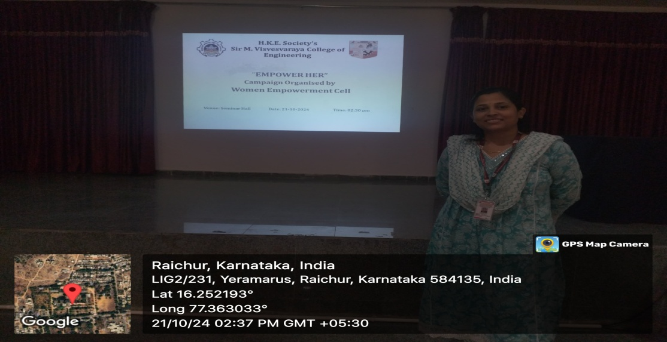

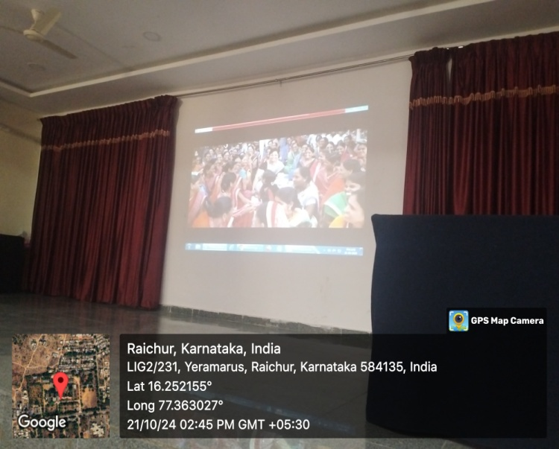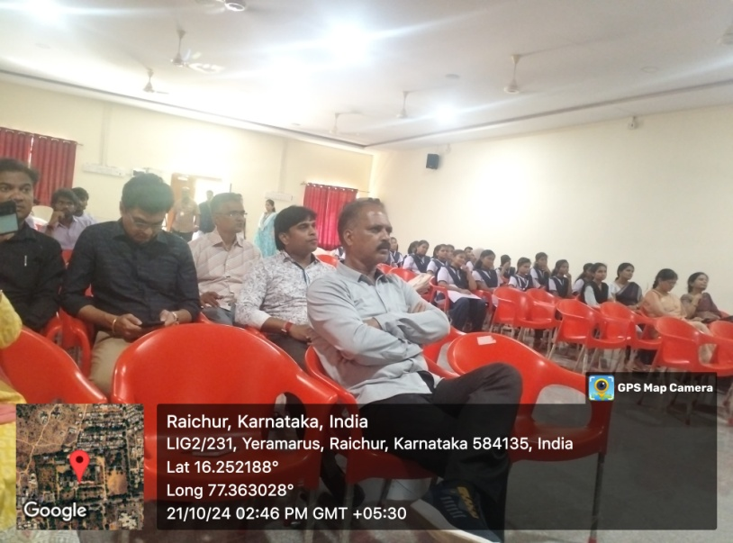

**CHAIR PERSON PRINCIPAL**