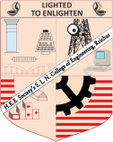
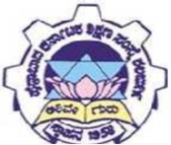
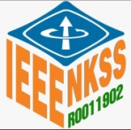
H. K. E. Society’s S. L. N. College of Engineering, Raichur
Govt. School Adoption
““Visualization Activities to Improve Academic Achievements “
Organized by IEEE Student Branch STB99080

24th August 2022 Time: 02:00 pm to05:00pm
No. of Participants: 54
This is the first activity after adopting Government Higher Primary school, Yaramaras camp Raihur.
On 24th August 2022 members of SLN-IEEE Student Branch and few staff of SLN College of Engineering, went to the school. All the members engaged the students in the activity of recognising and visualising 3d objects.
The activity was aimed at enhancing the learning of students. Students were given 2d and 3d objects they were allowed to see, touch and understand the calculations on regular geometric object.
Another session was for understanding the functioning of heart. Branch members explained functioning of human heart. Pictures and models were used for demonstration.
Total of 14 branch members volunteered in the event. 54 students from the school participated; they were very happy and joyous to be part of the activity.
Dr. Vishwanath P. IEEE Student Branch counsellor guided and monitored the activity.
Banner

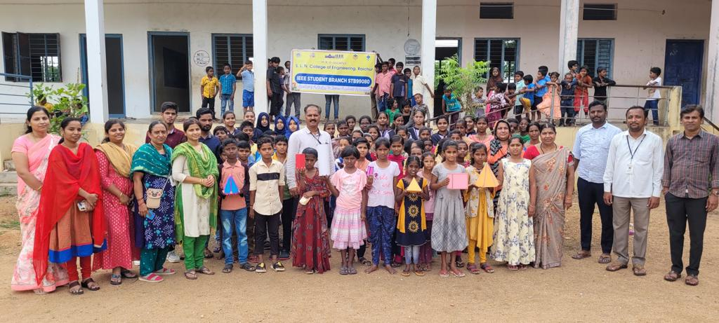
Glimpses
